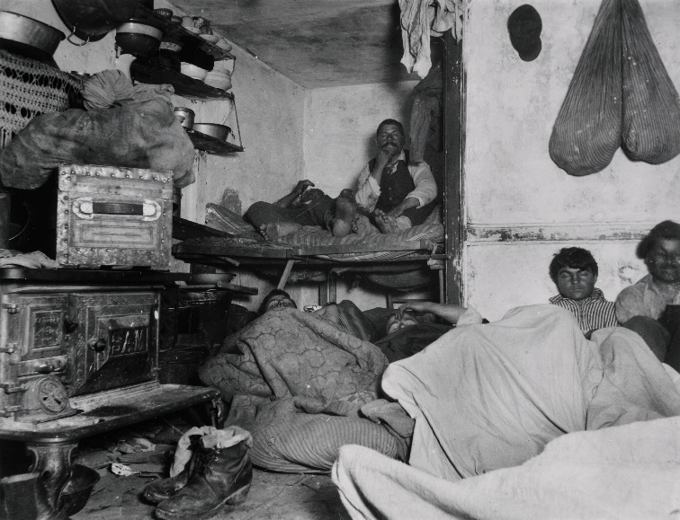

Before the beginning of the Progressive Era, many Americans were “cut out” of many aspects of everyday life. Children often were forced to choose to work in intensive labor settings over going to school. Working adults often worked 6 days a week in a factory, made little money, and were subject to unsafe working conditions.
But during the late 1800s and early 1900s, a movement began to form that changed life in America; the Progressive Era. In order to combine what you have learned from researching you presentation with the other topics that were presented, you are going to create a written response for me. You will write three paragraphs in the style that I have outlined below. Within each paragraph, you will answer the questions I have asked. Unless I have stated otherwise below, aim to answer these questions in 2-4 sentences per question.
Paragraph 1: Now that you have looked at many topics that took place during the Progressive Era, give me your own definition of the Progressive Era. Why did it start? How did communities go about brining positive change? How is this time period remembered today?
Paragraph 2: Thinking about the topic you presented, why was there a need to create change in this area (type of politician/movement/law) during the Progressive Era? (You should spend most of your paragraph answering this question or 3-5 sentences). How did this change help the average, everyday American?
Paragraph 3: Thinking about another topic that you observed, but DID NOT present yourself, what similarities have you noticed when compared to your topic? What differences have you noticed? Do you think this topic is more important to the average, everyday American today when compared to your topic? Why? (use the key facts from your presentation notes to help you answer the “why” portion of this question, or refer to chapters 4.2, 4.3, or 4.4 in Techbook)
I have provided you with an outline that you must complete before you begin writing. Mr. Wiesen must check over your completed outline before you begin writing. Your final written response due as a Google doc shared with Mr. Wiesen by Tuesday, September 13th, at the beginning of Social Studies class.

Name __________________________________

Paragraph 1:
- Give me your own definition of the Progressive Era. _________________________________________________________________________________________________________________________________________________________________________________________________________________________________
- Why did it start?
_________________________________________________________________________________________________________________________________________________________________________________________________________________________________
- How did communities go about brining positive change? _________________________________________________________________________________________________________________________________________________________________________________________________________________________________
- How is this time period remembered today?
_________________________________________________________________________________________________________________________________________________________________________________________________________________________________

Paragraph 2:
- Thinking about the topic you presented, why was there a need to create change in this area (type of politician/movement/law) during the Progressive Era? (You should spend most of your paragraph answering this question or 3-5 sentences)
__________________________________________________________________________________________________________________________________________________________________________________________________________________________________________________________________________________________________________________________________________________________________________________________________________________________________________________________________
- How did this change help the average, everyday American?
_________________________________________________________________________________________________________________________________________________________________________________________________________________________________
Paragraph 3:
- Thinking about another topic that you observed, but DID NOT present yourself, what similarities have you noticed when compared to your topic? What differences have you noticed?
_________________________________________________________________________________________________________________________________________________________________________________________________________________________________

- Do you think this topic is more important to the average, everyday American today when compared to your topic? Why? (use the key facts from your presentation notes to help you answer the “why” portion of this question, or refer to chapters 4.2, 4.3, or 4.4 in Techbook)

__________________________________________________________________________________________________________________________________________________________________________________________________________________________________________________________________________________________________________________________________________________________________________________________________________________________________________________________________

