*Directions- Step 1: Now that you have this document on your screen, SAVE it to your Google Drive with the title “Black Belt Analysis (last name)”. If I was doing this, mine would be “Black Belt Analysis Wiesen”. Step 2: After you SAVE, please SHARE this with me at awiesen@stmarybg.org. This will be homework due Monday, December 11th, 2017.
Complete steps 1 and 2 BEFORE you begin answering the questions below. Read all parts carefully and answer any parts that require your answer (I have marked those questions well.)
Here we go…
The Harlem Renaissance was a time of great cultural expression for African Americans. During this time, African American artists, poets, dancers, photographers, and scholars used their creative talents to express what it meant to be an African American. Although not all of these people lived or worked in New York City, the neighborhood of Harlem was an important enclave for the African American community during the 1920s and thus gave the cultural and artistic period its name. African American painter Archibald Motley was among the artists who painted images of contemporary African American life in the 1920s. In this activity, you will study and analyze one of Motley’s paintings, “Black Belt.” You will then use some of the artistic elements from Motley’s work to create your own drawing depicting the Great Migration and life for African Americans in the 1920s.

- Analyze a Painting from the Harlem Renaissance 1. Study the painting, “Black Belt.”
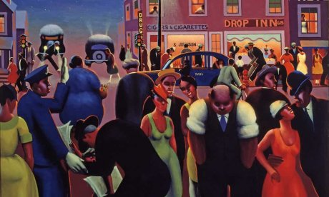

Directions: Answer the following questions IN COMPLETE SENTENCES using the painting above.
Question 1: Describe what is happening in this painting. What are the pieces of the painting that stand out the most to you? Considering what you have read in ch. 6.1 tabs 8-10 (your top 10 list), how does this painting exemplify African American life in the 1920s?
*your answer here*

Question 2: What emotions are depicted in this painting? How does the artist use light, facial expressions, and body language to make you feel or visualize these emotions?
*your answer here*
Question 3: Based on context, how do you think the subjects in the paintings feel about living here, in Chicago? Why?
*your answer here*
Question 4: What do you think the artist is trying to say with this painting? What evidence is there in the painting to support this argument?
*your answer here*

Artists typically use lines, space, and other elements and principles to emphasize the meaning and perspective of their paintings. “Black Belt” contains several of these artistic elements. Among these are: • Value, which shows changes in a base color to reflect the amount of light or darkness
• Texture, which uses lines and shading to make something look rough, smooth, or textured in another way
• Space, or the way the artist uses shading, color, and lines to make an area appear large or small
• Rhythm, the use of lines, patterns, shapes, and other elements to create a feeling of movement

4. Identify these elements of art in “Black Belt.” Based on your note taking on the painting, complete the table below. This portion DOES NOT require complete sentences.

Artist Technique | Evidence of this technique in “Black Belt”
Value, which shows changes in a base color to reflect the amount of light or darkness | *your answer here*
Texture, which uses lines and shading to make something look rough, smooth, or textured in another way | *your answer here*
Space, or the way the artist uses shading, color, and lines to make an area appear large or small | *your answer here*
Rhythm, the use of lines, patterns, shapes, and other elements to create a feeling of movement | *your answer here*

5. Summarize the author’s message or argument in “Black Belt” in 4-6 sentences. What is going on in the painting? What is the artist trying to convey?
*your answer here*

